Medical Lead Pipeline: Scraping, Verification, Cold Emailing, and Zoho CRM Sync
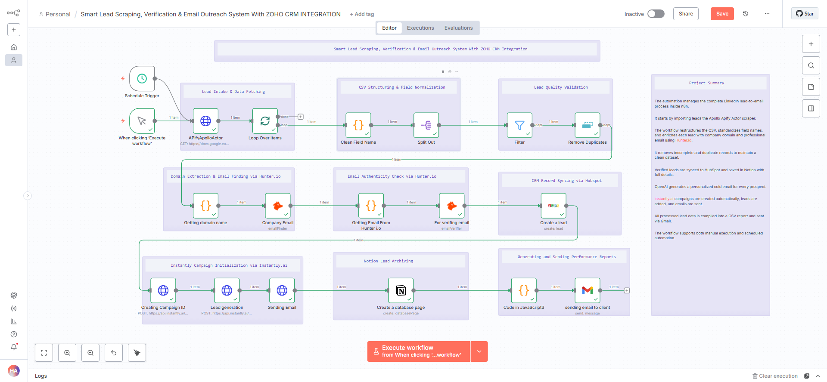
This project automates the full lead generation and outreach cycle using Apollo Apify data. It cleans and structures each Medical lead, extracts the company domain, and finds verified emails through Hunter.io. The verified leads move into Zoho CRM and are archived in Notion with complete details. Instantly.ai creates the campaign, adds each lead, and sends the cold emails without manual input. A CSV report for every processed lead is generated and delivered to the client through Gmail.

Scraping LinkedIn Leads
In this step, LinkedIn leads are scraped using the Apollo Apify scraper, which automatically collects company and contact details such as name, position, email, and company information. This ensures accurate, real-time data directly from LinkedIn for high-quality lead generation.
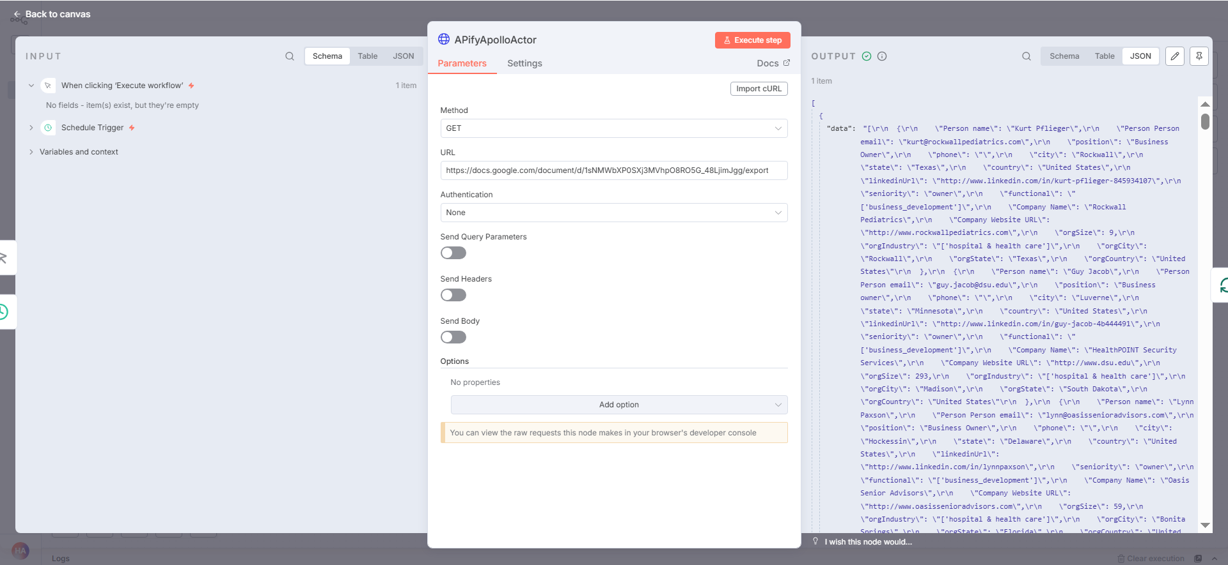

Finding Verified Emails using Hunter.io
Hunter.io is used to find and extract verified professional emails for each company, ensuring only valid and reachable contacts are added to the workflow

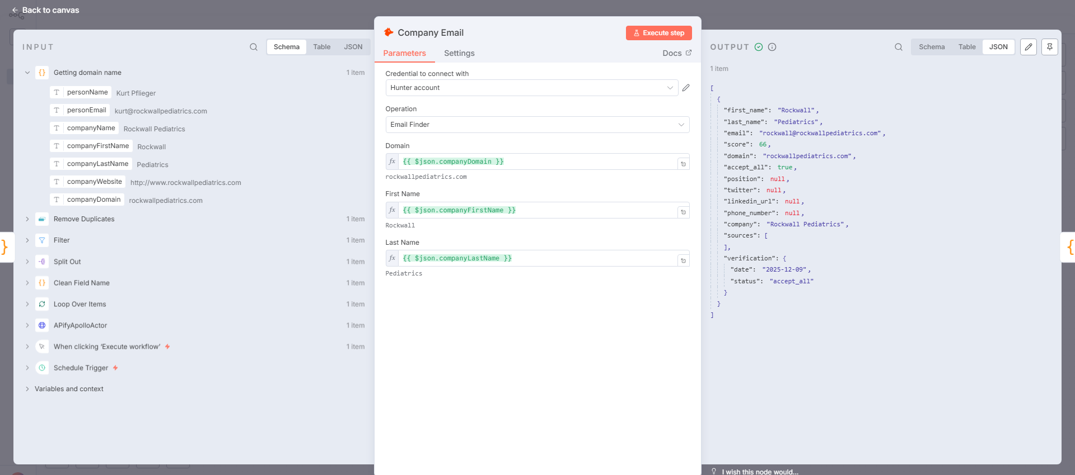

Verifying Email Accuracy
Each email is verified through Hunter.io’s email verifier to confirm its validity and reduce bounce rates during cold email campaigns
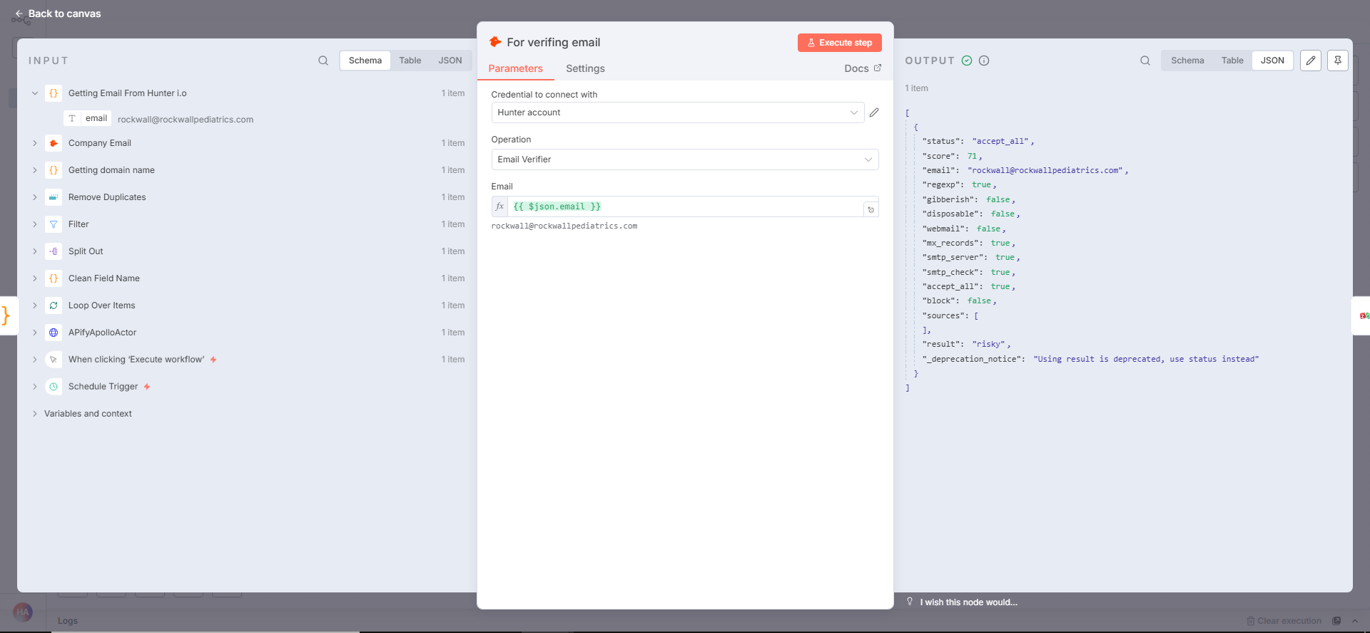

Syncing Leads with CRM (ZOHO CRM Integration)
Verified leads are automatically synced with ZOHO CRM, where new contacts are created or existing ones are updated to keep the database organized and up to date
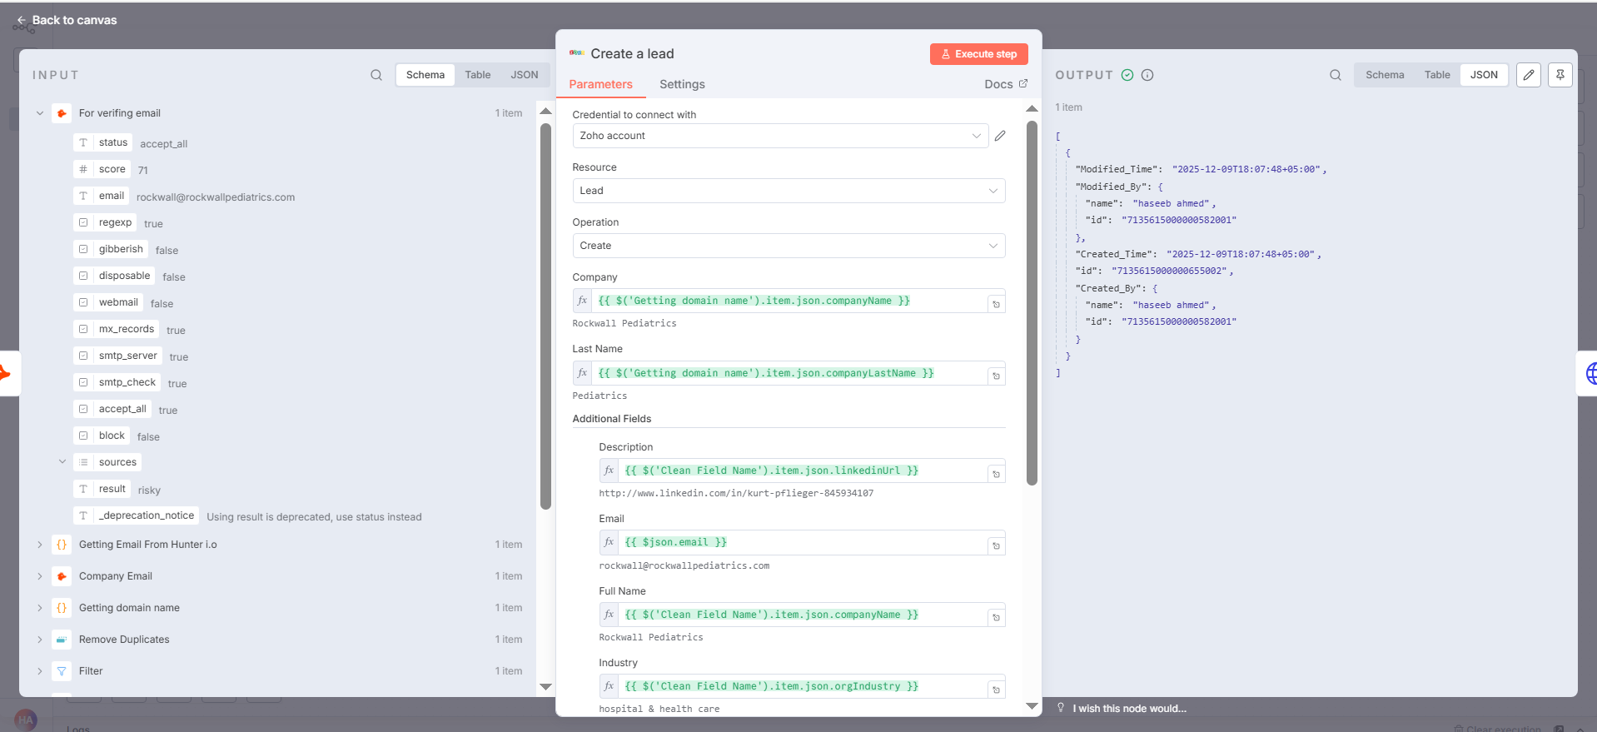

Launching Email Campaigns via Instantly.ai
Workflow connects with Instantly.ai to create and launch automated cold email campaigns, sending personalized messages to verified leads at scale
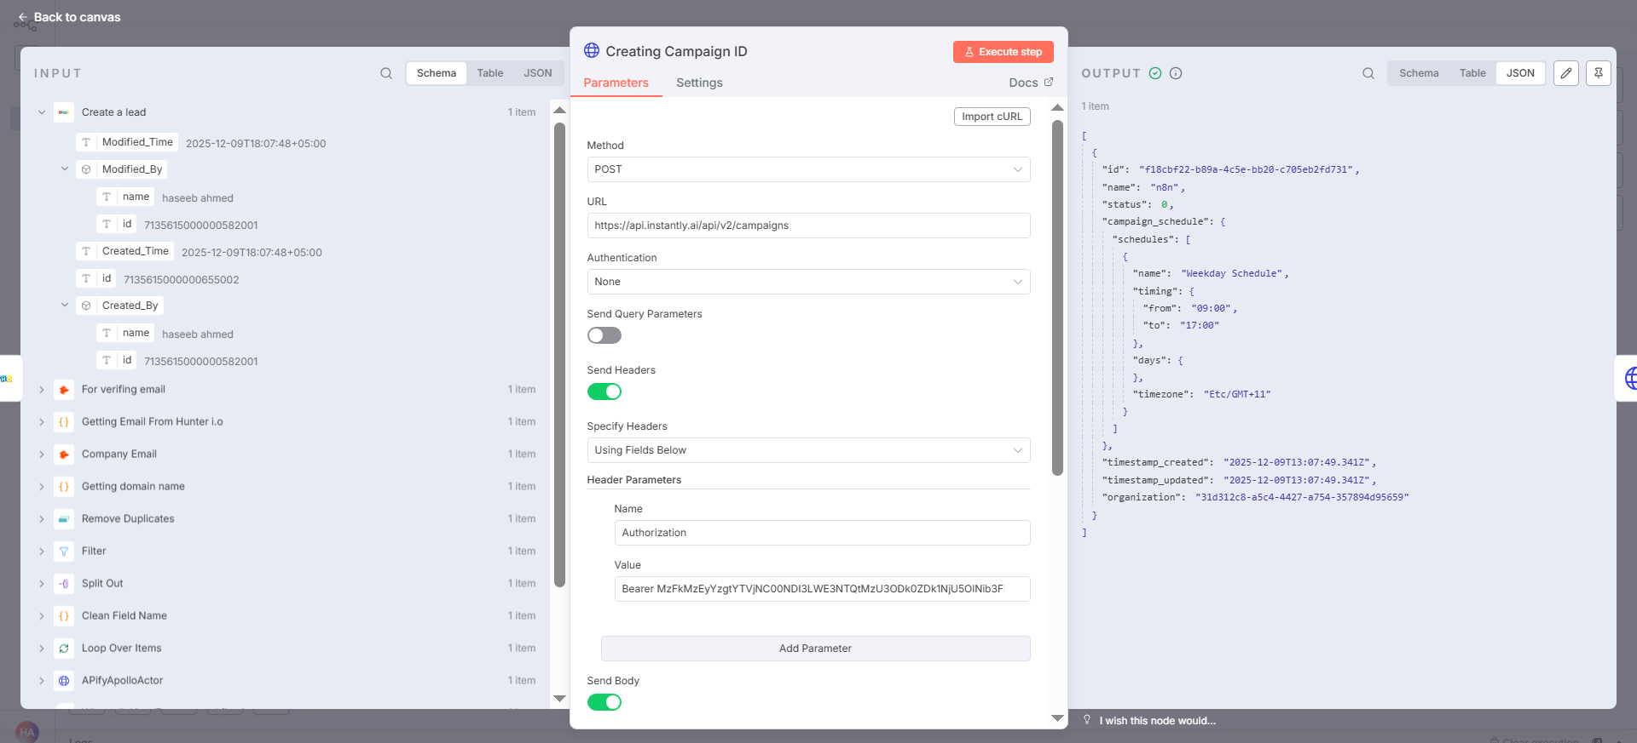

Saving Leads and Campaign Data to Notion
All lead details and campaign results are automatically stored in Notion, providing an organized and easily accessible record of your outreach activities
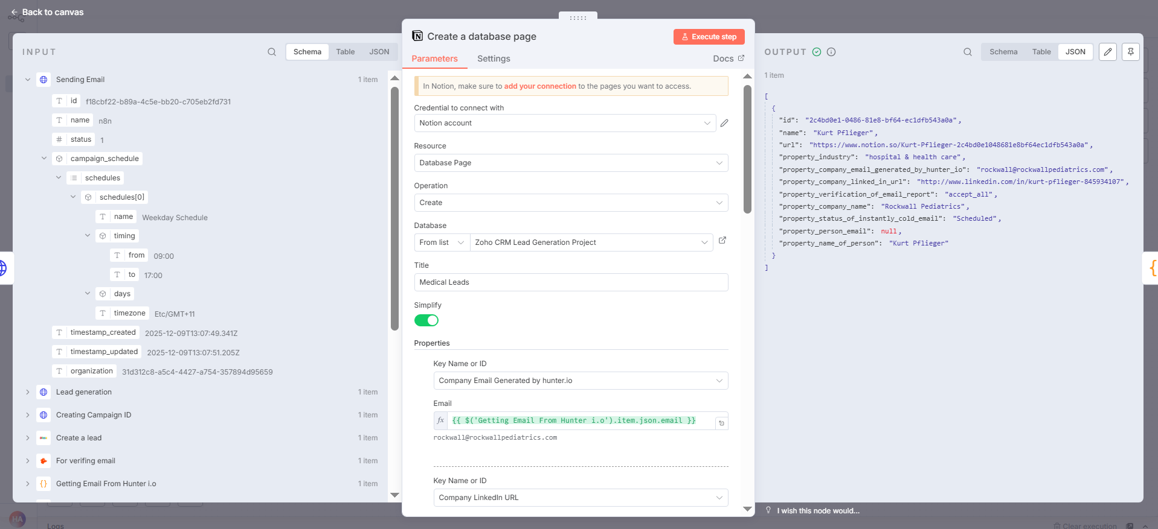

Generating and Sending Performance Reports
Detailed performance report is generated, summarizing leads, email statuses, and campaign results, and is automatically sent to your email for easy tracking

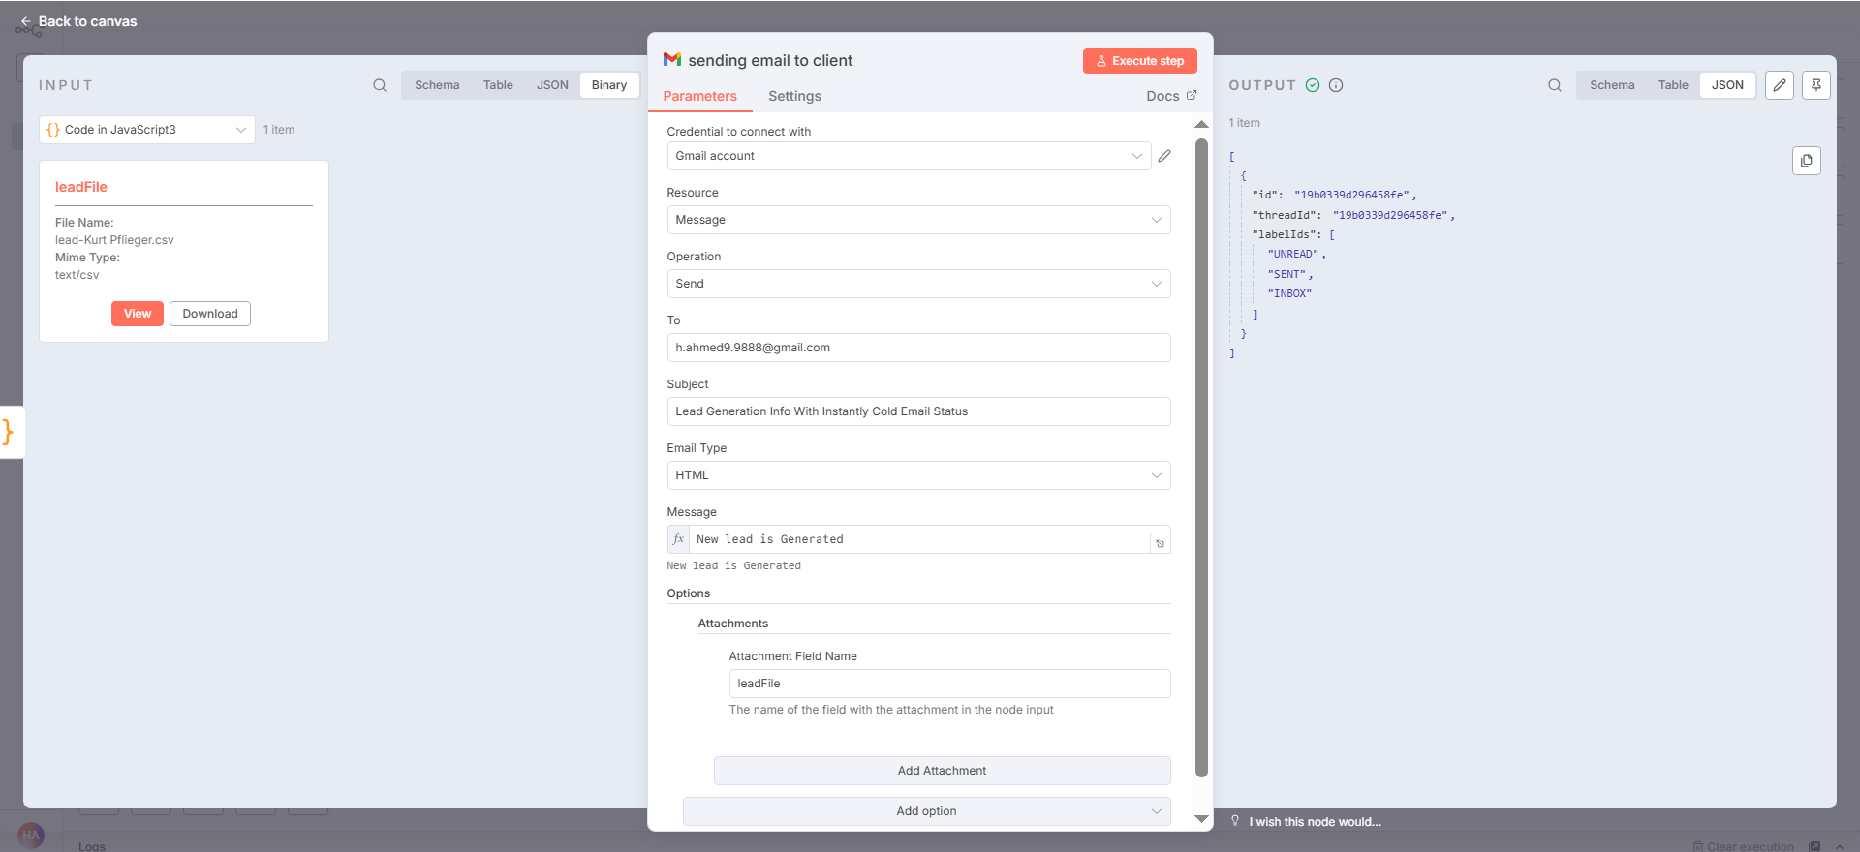

Hunter.io is used to find and extract verified professional emails for each company, ensuring only valid and reachable contacts are added to the workflow

